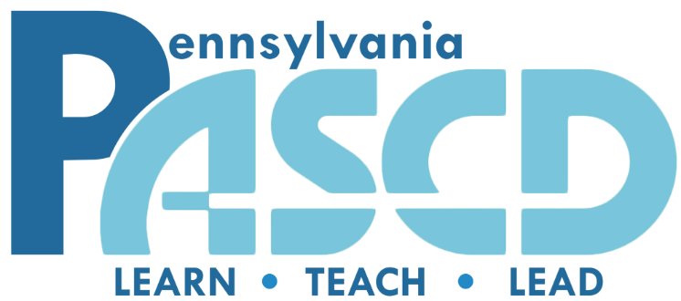

2023-2024 STUDENT SCHOLARSHIP INFORMATION

We are very excited to announce the PASCD 2023-2024 PASCD Scholarship.

Important information can be found on the back of this page. Please note, all information and digital copies of this packet can be found at https://pascd.org/Scholarship

Deadline: All information should be received by 11:59 PM on April 30th, 2023 to the following email address: PASCDscholarship@gmail.com. ALL information should be sent in ONE PDF document with the student’s first name initial, last name and current college (Ex. F. Yerace Bloomsburg).

The application packet must be completed according to the directions set forth in this application. Incomplete or late applications will be disqualified.

Responsibility:
It is the responsibility of the student to make sure the application has been completed according to the directions and emailed prior to the deadline.

Information:
- Before completing the application, please read all of the contents carefully.
- Applicants who may have further questions about the application procedures may call, or email:
Dr. Felix Yerace
fyerace@southfayette.org or PASCDscholarship@gmail.com
(412) 221-4542 x603

The Pennsylvania Association for Supervision and Curriculum Development
is not responsible for lost, incomplete, or late applications
or applications sent to the wrong email address.

Contents of the Application

Eligibility Requirements (no exceptions will be made):
- Students must be legal permanent Pennsylvania residents enrolled in their second, third or fourth year of studies at a public or private college/university in Pennsylvania in the 2023-2024 academic year. A fifth year of study, for the purposes of earning teacher certification, will be accepted.
  - A legal permanent Pennsylvania resident means that the applicant would qualify for “in-state” tuition if they were attending a public university (i.e., a state-related institution such as the University of Pittsburgh, or a member of the State System of Higher Education, such as Bloomsburg University).
  - Applicants do not need to be attending a public university to be eligible for this award, but, they must be able to qualify for Pennsylvania in-state tuition if they were attending one of these schools in order to apply for this award.
- Students must be full-time in an educational major or certification program.
  - Dual majors are allowed to apply so long as one of those majors is education, or a teacher certification program.
- The completed application and transcript must be emailed by 11:59 PM on April 30th.
Reasons for Application Disqualifications:
- Ineligibility of applicant
- Incomplete application
- Lateness
- Falsification of any information on the application (regardless of who falsified the information)
Application Procedures:
- Student types or prints name on all pages of the application.
- Student types or prints Part I, II, and III (Pages 1-3) and signs and dates the Applicant’s Statement. Student signature is to be in black or blue ink.
- Parent completes Part IV (Page 4), and returns Part IV. Type or print clearly using black or blue ink.
- Professor completes Part V (Pages 5-6) signs and dates, and returns Part V to the student. Type or print clearly using black or blue ink.
  - If the professor prefers to send Part V back without the applicant seeing the form, they may submit the materials directly to PASCDscholarship@gmail.com. Please note this is not preferred by PASCD and should only occur if the instructor insists on it.
- Advisor completes Part VI (Pages 7-8) signs and dates, and returns Part VI to the student. Type or print clearly using black or blue ink.
- Student sends by email completed application in one document, e-mailed no later than the deadline of 11:59 PM on April 30th, 2023.
- Student should include most recent unofficial transcript so that it is emailed as part of the complete package –one document. Please take the time to include the transcript with the rest of the application in one document.

Selection Process:
- The applications are reviewed and scored by a committee of professional educators utilizing a rubric to ensure fairness.
- The selection process is weighted with emphasis placed on:
  - Scholarship (GPA) and references.
  - Written expression on essays.
  - Extra-curricular activities/project and/or awards/recognitions.
  - Need
- Applicants will be notified of the status of their applications by August 30th.
- Scholarship check for $2,000 or $3,000 will be sent directly to the college/university indicated on the application for your Fall 2023 semester.
  - The scholarship check will not be released until PASCD has received a copy of your Fall 2023 tuition invoice from your institution.
- Winners will be invited to the Annual Pennsylvania ASCD Conference in November and will be introduced to the conference participates and asked to give a brief thank you.
- Please note: Winners will be expected to furnish the W-2 and/or tax returns of their parents to verify the need based portion of the application. Failure to do this will result in the winner not receiving the scholarship.

